Add a Slide to Billboard

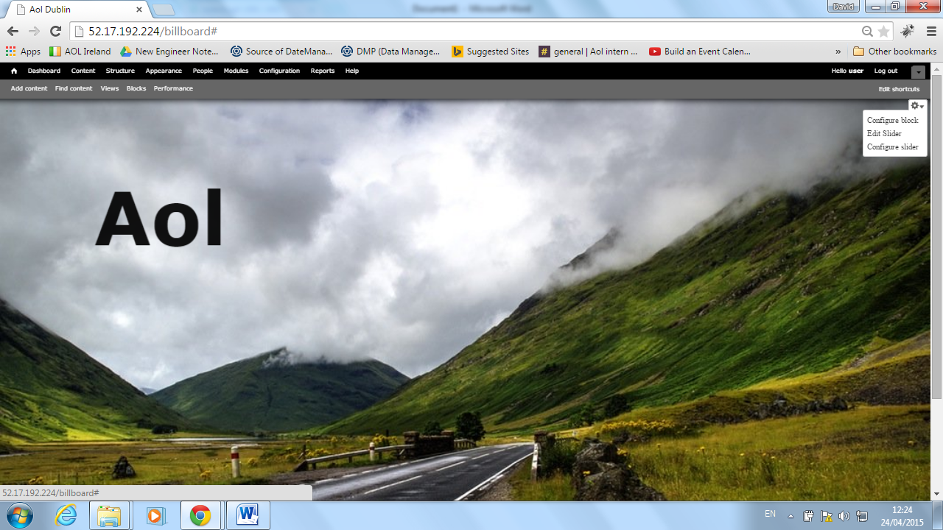

Fig 1.0

1. Navigate to the billboard screen
2. Move mouse over image in the billboard, a settings cog will appear in top right hand corner
3. Click settings cog and select “**Edit Slider”**

## Add New Slide with Background Image

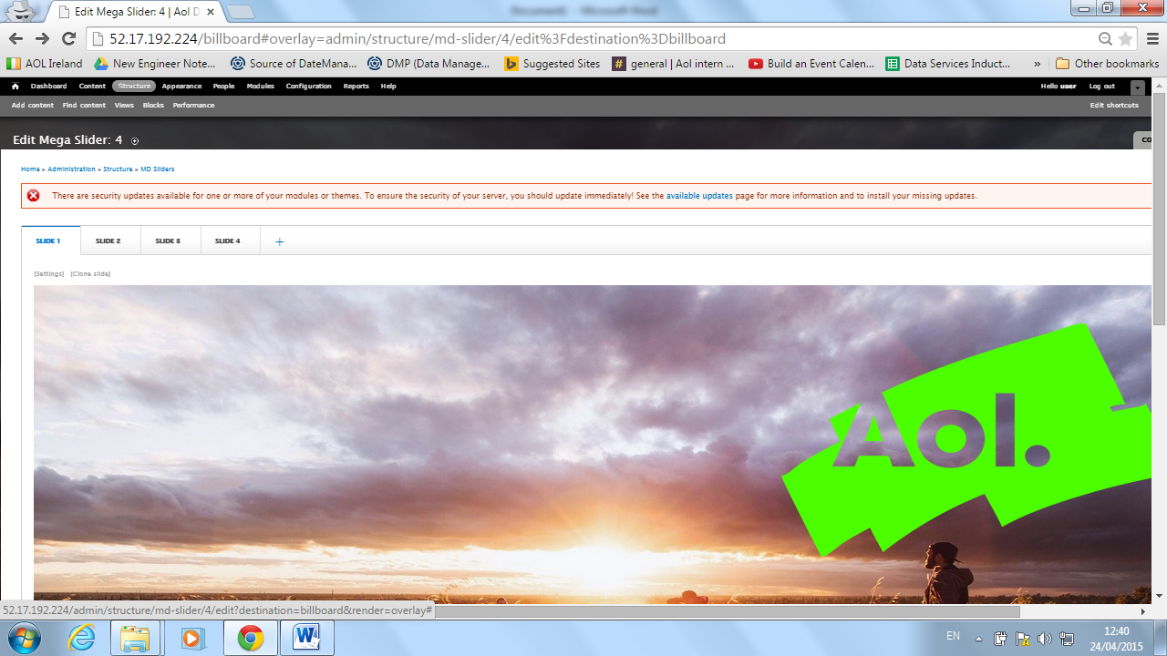 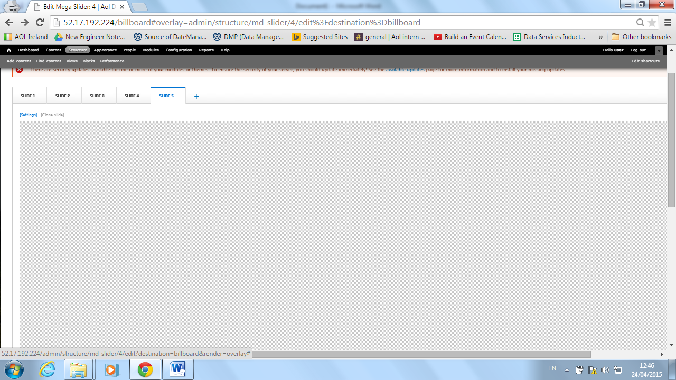

Fig 2.0 Fig 2.1

1. Click the “**+**” symbol at the end of the slide selector bar as seen in Fig 2.0
2. Click “**Settings**” highlighted in figure 2.1
3. Click “Choose image” link to set the background link
4. Navigate to your chosen image and click Submit
5. Next chose your desired transition, this is the transition between slides, note if you hover over the transition a demo is shown
6. Click “**save**”
7. Slide is loaded with background image

## Slide Designer

Font Alignment

Font Style

Font Weight

Add Video

Add Text

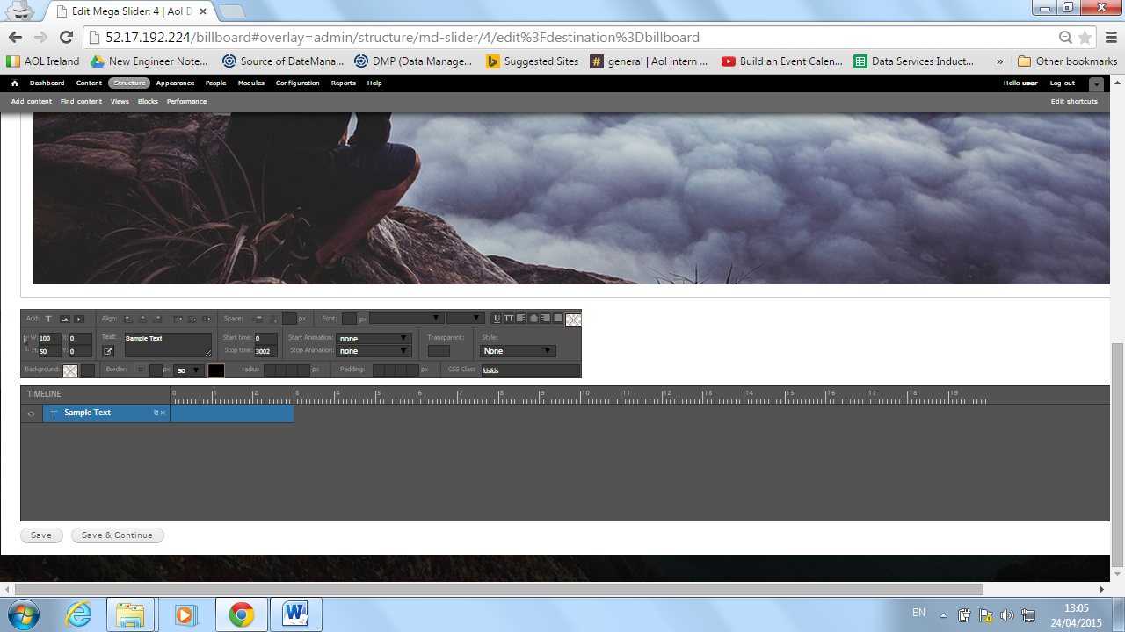

Make Element a Link

Font Colour

End Transition

Start Transition

Add Image

Font Size

Fig 3

1. Scroll to the bottom of the newly created slide
2. Click the “**T**” symbol as shown in fig 3 above to add Text to the slide, the input fields will populate automatically
3. Insert desired text in the text field
4. Set the font size
5. Set the desired font weight
6. Set desired font weight
7. Select the desired start transition effect, can be left empty if no transition
8. Select end transition effect, can be left empty if no transition
9. In addition to this the text can be dragged and dropped to any location on the slide

## Slide Timing

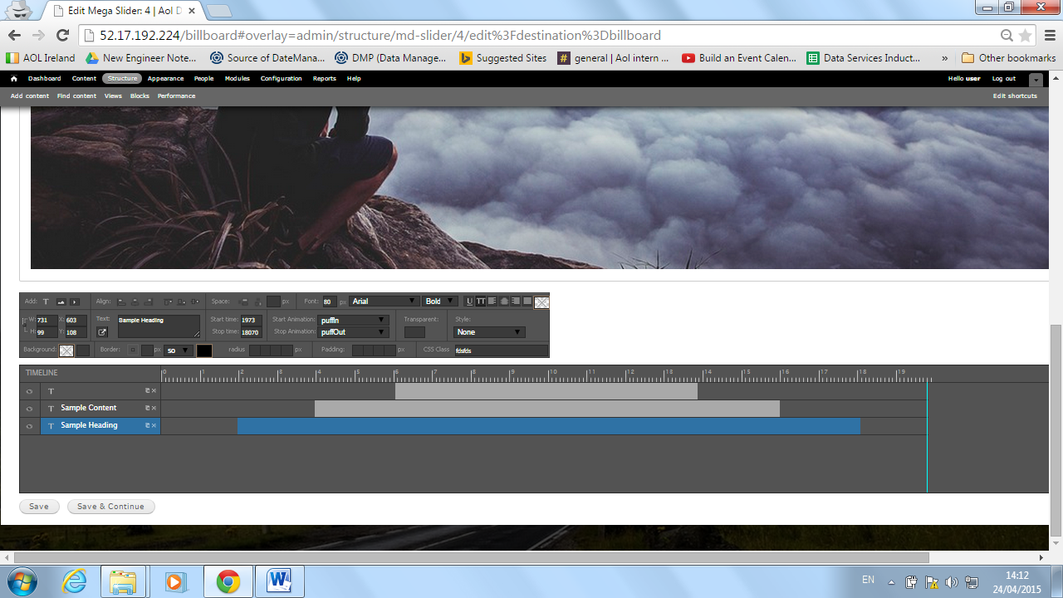

Total Slide Duration (seconds)

Element timing

Fig 4

The duration and timing of each element on the slide is customizable. If there is a lot of content on the slide it is advisable to split the content up and have it appear in a staggered manner. Figure 4 above shows the timeline section for the slide where each individual elements timing can be set.

1. To **set the total time for the slide**, select the vertical blue line and drag to the left or right to the desired time. The maximum time a slide can be set to is 20 seconds
2. To **select when to show an element**, click and hold the left side of its highlighted timing field and drag left or right to the appropriate time location
3. To **select when to hide the element** again, click and hold the right side of its highlighted timing field and drag left or right to the appropriate time location

**When the slide is set up the way you would like it, do not forget to click the save button below the timing section or your changes will be lost when you navigate away from the page.**